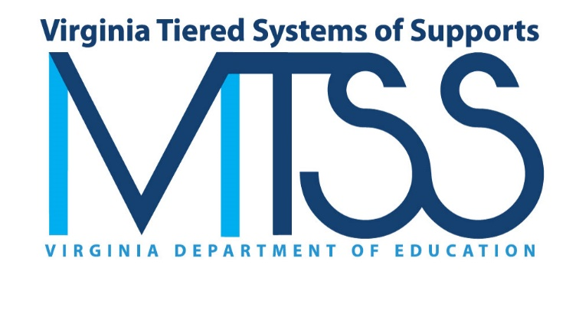

2022-2023 Annual Report

Introduction
The Virginia Department of Education (VDOE) seeks to help every learner meet high expectations. The Virginia Board of Education has identified this as its first priority within the VDOE’s Comprehensive Plan 2024-2029. Ongoing Board priorities include supporting teachers, school, and community leaders in providing effective support to a diverse student body.
As a part of this effort, the VDOE established the Virginia Tiered Systems of Supports (VTSS) and the VTSS-Research and Implementation Center (VTSS-RIC) at Virginia Commonwealth University to support implementation of a multi-tiered systems of support (MTSS). The VTSS, led by the VDOE, collaborates with state universities to provide coaching, technical assistance, and professional learning to school division teams to establish and sustain implementation of their MTSS. The vision of the VTSS is to build sustainable multi-tiered systems of support through collaboration with divisions, schools, families, communities, and students that results in equitable and improved academic, behavioral, and social emotional outcomes for all.
Through this network of technical assistance, VTSS State Systems Coaches work with school division teams to establish a decision-making framework. This framework provides a system to integrate academic, behavioral, and social-emotional wellness supports. The VTSS approach facilitates the ability of divisions, schools, and communities to provide multiple layers of support to students in an effective, clearly defined process.

Report Structure
In this report, implementation efforts are reported for the domains of reach, process, capacity, and outcomes along with VTSS focus areas of early childhood and family engagement which both highlight VTSS implementation efforts.
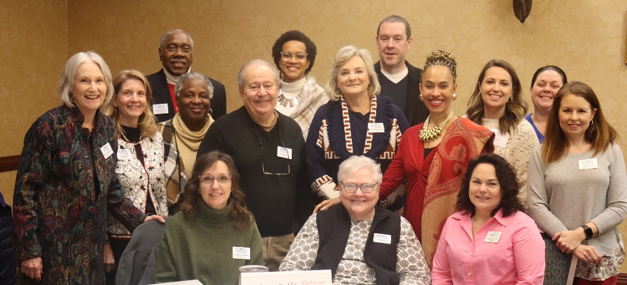

Timeline of Support for Tiered Services Initiatives in Virginia
Since 2007, the Virginia Department of Education has received eight federal grants focused on providing tiered supports to students in schools. These grants have included four State Professional Development Grants (SPDGs), two federal School Climate Transformation Grants (SCTGs), a Project Aware Grant, a Personnel Development Grant (PDG), and a School Based Mental Health Grant (SBMH).
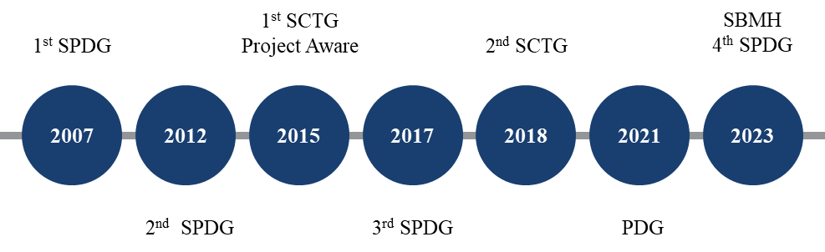
These grants have funded the evolution of tiered systems of support initiatives in Virginia. Implementation milestones include:
- 2005: Effective School-wide Discipline (ESD) was established to support positive behavior change through tiered supports.
- 2007: Response to Intervention (RtI) was initiated to a provide multitiered system of academic supports.
- 2008: ESD was rebranded Positive Behavioral Interventions and Supports (PBIS) of Virginia.
- 2012: The Virginia Tiered Systems of Supports (VTSS) was established through the integration of PBIS and RtI supports within a multi-tiered systems of support (MTSS) framework.
- 2015: VDOE focused on enhancing and scaling-up tiered systems of support along with introducing mental health into the tiered systems. Additionally, the VTSS-Research and Implementation Center (VTSS-RIC) was created to build state capacity to support training and technical assistance.
- 2021: VDOE expanded efforts toward retaining Special Education Teachers through a MTSS framework.
- 2023: VDOE expanded efforts toward recruiting and retaining school-based mental health providers through a MTSS framework.

Reach

The Virginia Tiered Systems of Supports provides coaching, technical assistance, and professional learning opportunities to nearly 50% of Virginia’s school divisions.

56
Divisions
947
Schools
702,215
Students

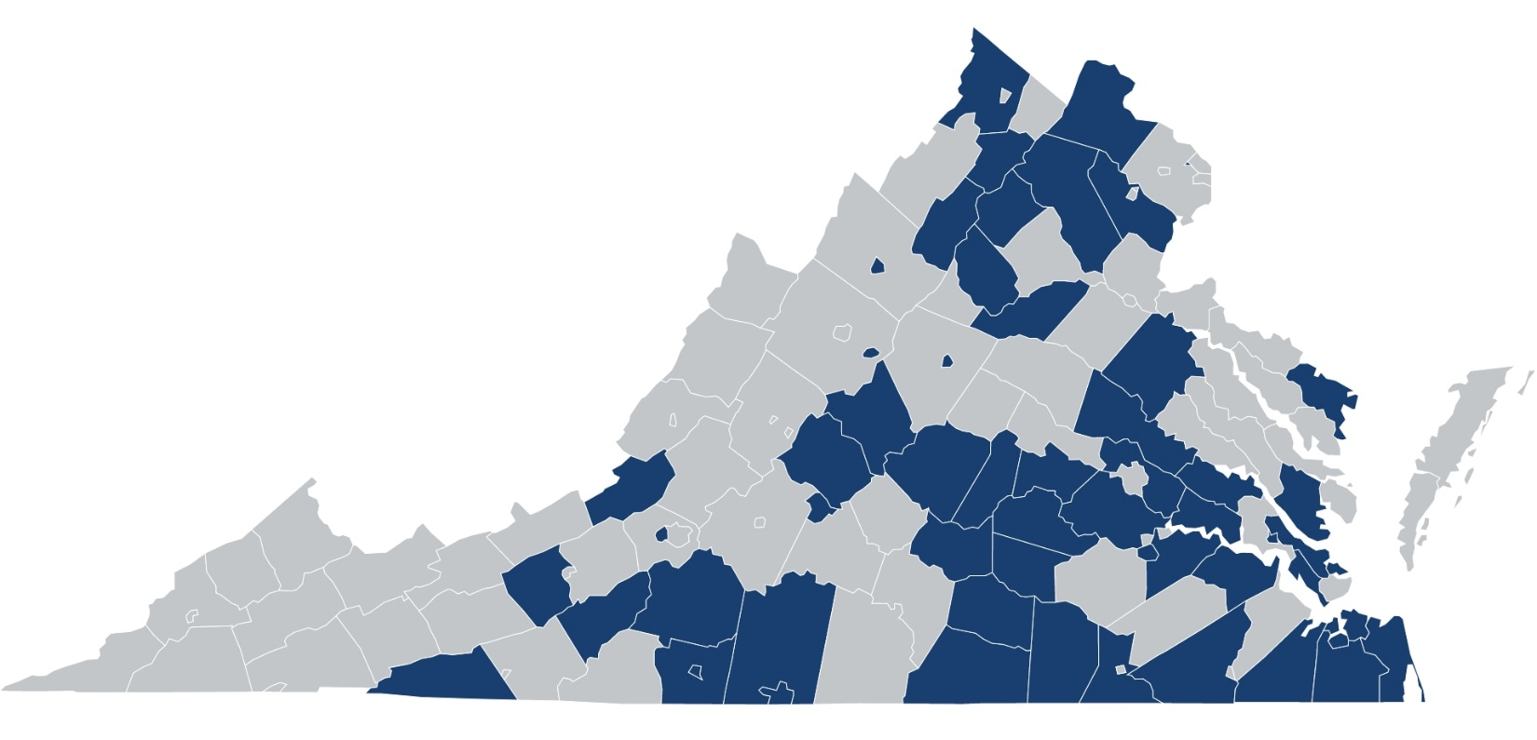

Professional Learning Events
In 2022-2023, the Virginia Tiered Systems of Supports staff hosted professional learning events for 980 participants.

Website Visitors
In 2022-2023, the Virginia Tiered Systems of Supports had 16,459 individual website visits of which 8,905 were new users.

Professional Learning Participants
- Central Office Personnel
- Community Mental Health
- Division/School Coaches
- Early Childhood Personnel
- General Education Teachers
- Parents/Family Members
- Related Service Providers
- School Administrators
- Special Education Teachers
- Student Services

Process: Training
During the 2022-2023 academic year:
18 Events
980
97%
18 Training Events with 980 total participants across the training events
13 Professional Learning Community (PLCs) and Networking Events with 312 total participants across the professional learning community and networking events
13 PLCs
312
97% of participants agreed or strongly agreed that the training events aligned with their division’s standards and goals
98% of participants agreed or strongly agreed that the training events emphasized the impact of the content on student outcomes
98%
97% of participants agreed or strongly agreed that the training events improved their knowledge of MTSS
97%

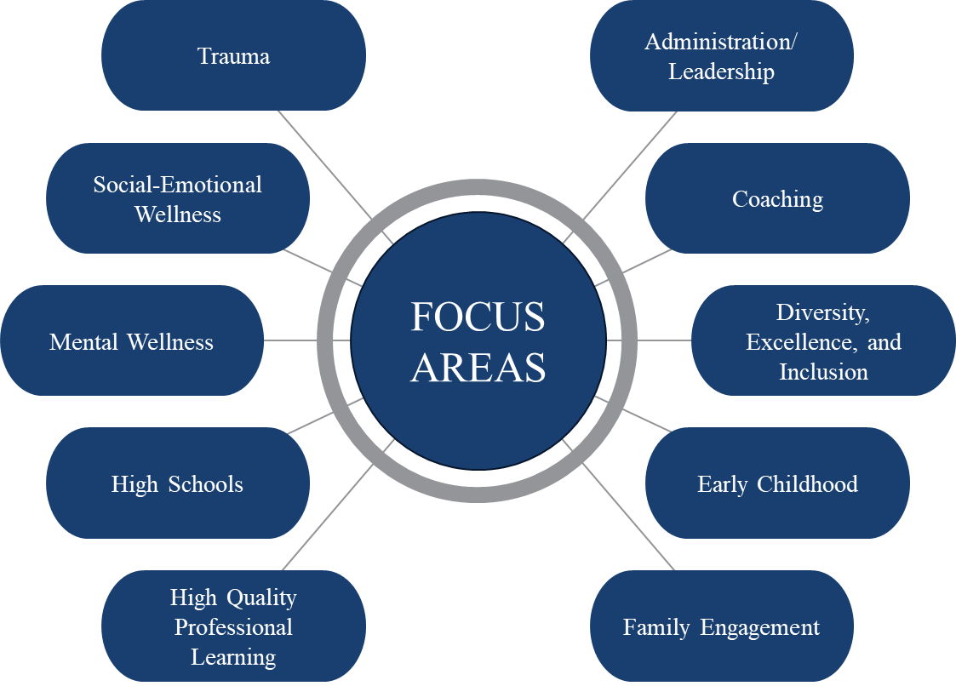

Process: Technical Assistance and Coaching

VTSS has a cadre of trained and skilled state Systems Coaches to provide technical assistance (TA) and coaching at the regional and local levels.
Of the divisions that responded to a survey:
100% agreed or strongly agreed that the collaborative work between their division leadership team and VTSS is valuable to implementing tiered systems of support in their division.
94% agreed or strongly agreed that VTSS Systems Coaches have helped their division team develop a framework to implement tiered systems of support with fidelity.
94% agreed or strongly agreed that support from VTSS Systems Coaches resulted in identification of action items that will help build the sustainability of MTSS in their division.
During the 2022-2023 academic year, there were more than 2,000 TA/coaching events.

Each year VTSS State Systems Coaches write coaching plans for the divisions they support. They select focus areas for coaching supports to improve division implementation of MTSS.

Capacity
29 Divisions  Twenty-nine divisions have acquired the capacity to support building-level implementation of MTSS.  8 Divisions  Eight are fluent in the capacity to support building-level implementation of MTSS. | 42 Divisions  Forty-two divisions have at least one internal coach to support schools in their implementation of MTSS.

VTSS State Systems Coaches
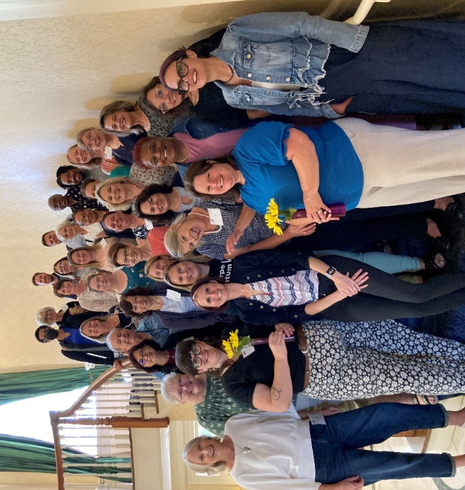
VTSS State Systems Coaches coach division and school level teams to build organizational capacity to sustain multi-tiered systems of support (MTSS) implementation.
“The [VTSS State Systems Coaches] we have worked with over the past several years have been outstanding. They provide valuable training, help explain processes to division leadership, and provide direct support services. They are invaluable to our efforts to implement a tiered system of supports with fidelity. Their expertise and knowledge basis have helped us move the needle in our division-wide implementation process.”
York County Public Schools

VTSS Resources

- VTSS Implementation Matrix
- Division Initiative Mapping
- Resource Map and Tier Definitions
- Assessment Map
- Action Planning
- Division Capacity Assessment
- SWPBIS Tiered Fidelity Inventory
- Academic Tiered Fidelity Inventory
- Coaching Service Delivery Plan
- Evidenced Based Practice Selection Tool

Outcomes: Academics
During the 2022-2023 academic year, 319 division and 174 school TA/coaching events focused on improving academic outcomes.
500 TA/Coaching events on improving academic outcomes
VTSS has defined High Implementing Schools as schools that have been implementing MTSS with fidelity for the past 3 years (2020-2021, 2021-2022, and 2022-2023).
- English-Reading Pass Rates higher than the state
    - 55% of High Implementing Schools for Black students
    - 59% of High Implementing Schools for students who are economically disadvantaged
  - Mathematics Pass Rates higher than the state
    - 58% of High Implementing Schools for Black students
    - 65% of High Implementing Schools for students who are economically disadvantaged
  - Graduation Rates higher than the state
    - 70% of High Implementing Schools for Black students
    - 60% of High Implementing Schools for students who are economically disadvantaged
    - 60% of High Implementing Schools for students with disabilities
67% of VTSS divisions have English-Reading pass rates greater than the state for Hispanic Students.
69% of VTSS divisions have Mathematics pass rates greater than the state for Hispanic Students.
51% of VTSS divisions have graduation rates higher than the state for Black Students.
73% of VTSS divisions have graduation rates higher than the state for Hispanic Students.

Outcomes: Behavior and Chronic Absenteeism

During the 2022-2023 academic year, 731 division and 665 school TA/coaching events focused on improving behavior outcomes including attendance.
1400 TA/Coaching events on improving behavior outcomes
From 2021-2022 to 2022-23,

150 schools reduced their number of Office Discipline Referrals by at least 10% for all students and for students with disabilities.
8 VTSS divisions reduced their % chronically absent for all students by at least
4 percentage points.
13 VTSS divisions reduced their % chronically absent for students with disabilities by at least 4 percentage points.

Caroline County Testimonials
Bowling Green Elementary School implements and sustains a tiered system of support along with the House System which is a system which gives all students the opportunity to be part of a group, team, and family. These two systems helped the school improve our culture and attendance rate. Through this work, Bowling Green was able to go from a Chronic Absenteeism rate of 25% for 2021-2022, to a 21% rate for 2022-23. We have continued to refine our practices based on data and expect a further decrease in Chronic Absenteeism by continuing to incorporate the process and procedures based on the structure provided by MTSS.
Lewis and Clark Elementary School focused on school climate and culture for the 2022-2023 school year. Our school mascot is a grizzly bear so we developed five dens and sorted our students and teachers to the different dens. Our students are meeting friends from all different classes and grade levels and learning how to be family in our Grizzly Nation. Creating a sense of belonging is a key piece for our students as they continue to grow academically, socially, and emotionally at Lewis and Clark Elementary School.
Madison Elementary School has a behavioral matrix with expectations for all areas inside and outside the building. Students are given positive referrals for following these expectations for which students can select a prize from our office prize cart weekly. Teachers recognize students in classrooms for demonstrating our expectations including academic success and attendance. Monthly AttenDANCE celebrations recognize students with perfect attendance. We have monthly House Competitions (We are five houses, one family) and celebrations for the house that receives the most points for behavior, culture, and academic success. These activities are helping to maintain academic accreditation and decrease our behavioral referrals.

Family Engagement

Components of Family Engagement
Positive Relationships
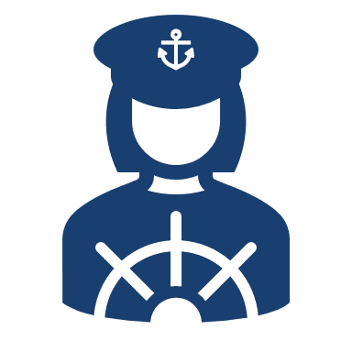
Family Empowerment
Strong and Shared Leadership
Data-based Goals and Outcomes
Multidimensional Communications
Multi-tiered Approaches
Collaborative Problem Solving

Resources
Formed Families Forward and VTSS partnered to create a series of video and print resources for divisions, schools, and families.
- Family Engagement in VTSS
- Family Members on VTSS Teams
- Promoting Equity in Education Through Family Engagement
- Strengthening Family Engagement in VTSS
- Trauma Sensitive Approaches for Home and School

Division Examples
Divisions are increasing opportunities for authentic family engagement in MTSS by cultivating a culture of open, effective communication and targeted approaches for ‘doing with’ families.
- Williamsburg-James City County Public Schools elevated voices of diverse families with a Disability Awareness and History Month panel event.
- Chesterfield County Public Schools created engagement videos to share reading strategies families can use at home to reinforce those used at school.
- Caroline County Public Schools hosted monthly Grandparent Group meetings to build skills of kinship families and deepen community.
- Henrico County Public Schools addressed chronic absenteeism using summer engagement teams who call families, visit homes, and provide resources in local apartment complexes to connect and engage families.
100% of divisions that accessed a resource reported the resource as valuable.

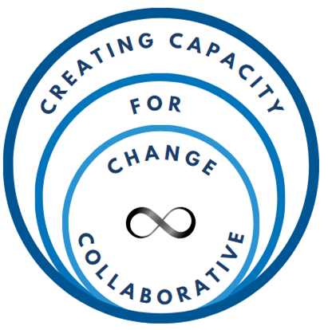
Creating Capacity for Change and Continued Professional Growth (CCC)
The Virginia Personnel Development Grant, Creating Capacity for Change and Continued Professional Growth (CCC), falls under the VDOE VTSS initiative, which focuses on the implementation of innovations and practices through MTSS. CCC extends the core components of MTSS to retention of special education (SPED) teachers. Chesapeake City partners with VTSS to participate in CCC with over 500 SPED teachers.

Project Goals
- Improve quality of teacher candidate and in-service teacher preparation.
- Division and school leaders make data-driven decisions about retaining SPED teachers.
- Improve SPED teacher retention rates in pilot sites and participating divisions.

2022-2023 Implementation Milestones
- Chesapeake reviewed special education teacher retention data to determine inclusion and exclusion criteria for staff participation.
- Cohort 1 teachers participated in a special education teacher academy where they received Tier 1 curriculum including:
  - Personal wellness, resilience, and time management
  - Individual Education Plans (IEP) process and role in instruction
  - Eligibility determination and Specially Designed Instruction
  - Prior Written Notice
  - Data, Practices, and Systems
  - Understand how special education fits within MTSS
- Ultimate Behavior Toolkit Modules:
VDOE developed and produced modules in support of improving teacher preparation. These modules are available on the VDOE website and were assessed as high-quality by external expert reviewers. These modules have been embedded in SPED teacher licensure work at Old Dominion University (ODU).

- Clear Classroom Rules
- Behavior Contracts
- Precorrection
- Conflict Resolution
- Anger Management
- Establishing a Positive Environment
- A Behavior Intervention Plan
- Positive Behavior Interventions & Supports (PBIS)
- Crisis Management
- Accommodations for Students with Disabilities
- Data Collection/Analysis for Intervention Plans

Virginia’s Comprehensive Approach to Recruitment and Retention of SMHPs
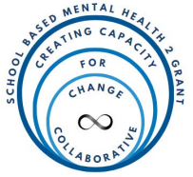
The 2022 School Based Mental Health Grant (SBMH 2) S184F220101 is the second iteration of the SBMH Grant out of the United States Department of Education. The 2022 iteration of this grant is funded through the Appropriations Act and the Bipartisan Safer Communities Act, with the goal of increasing the number of credentialed school-based mental health service providers in local educational agencies with demonstrated need (USED 87 FR 60137, 2022). This grant was initially funded in response to student mental health concerns that arose after changes in educational service models for students across the United States in the wake of COVID-19.
The Virginia SBMH 2, Virginia’s Comprehensive Approach to Recruitment and Retention of School Mental Health Professionals, aligns with the VDOE VTSS initiative extending the core components of MTSS to recruitment and retention of school mental health providers (SMHPs). SBMH 2 partners with 8 Virginia divisions with approximately 50,000 students across the divisions.

Project Activities
- Supporting division-level recruitment and retention planning for SMHPs to define short- and long-term needs and division action steps.
- Providing targeted professional learning to build recruitment and retention leadership capacity, SMHP specific skills, and implementation skills.

Proposed Outcomes
- Each participating division will increase the number of SMHPs by two positions in year two which will be partially subsidized by project funds. Additional SMHP positions will be added during years three through five using internal resource allocation.
- Students will receive increased access to mental health services from SHMPs in the divisions.

Implementation Milestones
SBMH 2 began implementation on January 1, 2023. Participating divisions established leadership teams that participated in monthly microteaching sessions which initiated division comprehensive retention planning activities based on the context of each division. The VDOE is planning a summer retreat, an Implementation Science academy, and additional microteaching sessions for the 2023-2024 academic year. The VDOE and VTSS is excited to report on the upcoming implementation milestones and outcomes in next year’s report.

Early Childhood

Preschool is Growing Up with VTSS
Early childhood care and education in Virginia is experiencing a rebirth in a very dynamic way. The primary driver for this rebirth is a vision where all children in Virginia have the opportunity to enter school ready.
The VTSS structure offers the necessary framework to build one cohesive, MTSS framework spanning from preschool through the early elementary years. The VTSS Early Childhood pilot has been investigating the systems level components and adjustments necessary for implementation and evaluation in schools serving young children. Initially, VTSS enlisted 3 school divisions as partners in this pilot to improve student outcomes. Click on the promotional video to learn more:
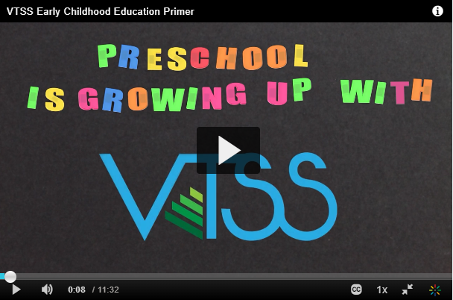

Virginia’s Unified Early Childhood System
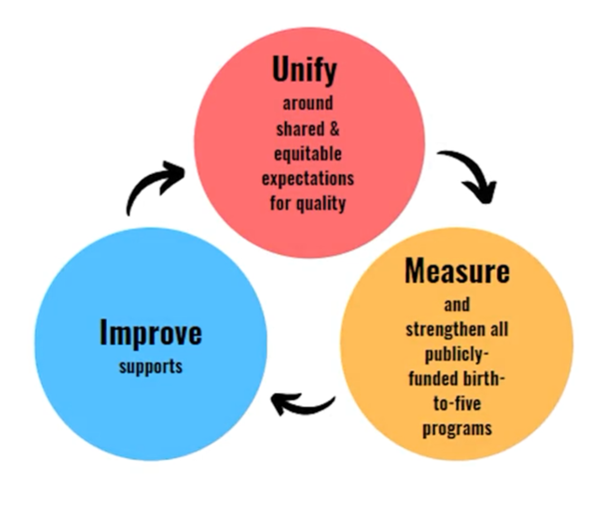
Scan to learn about VQB5:
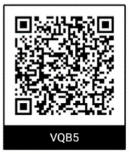

Frederick County, VTSS Early Childhood Partner
As a result of participating in the pilot, preschool is no longer a standalone entity and there is more collaboration among vertical teams and between schools:
- Preschool teams join the kindergarten teams during professional learning opportunities.
- Kindergarten teams work with 1st grade teams to develop stronger vocabulary transitions.
- When school begins, teachers better understand of where a child is developmentally.
- Schools collaborate when a preschool feeds students into multiple sites.
The division uses data informed decision-making to identify professional learning and resources on early literacy. Teachers use data to change instructional practices based on student need.

Collaborators
We would like to thank all those who collaborate with VTSS to make this work possible. Click on a logo to learn more.
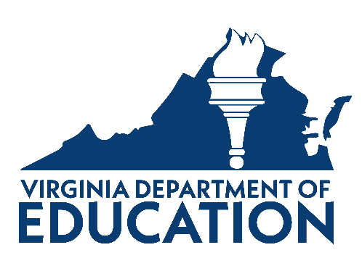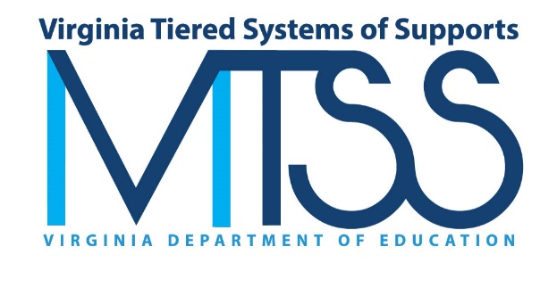
VTSS is supported by grants from USED:
- State Personnel Development Grant (H323A170018, H323A230002)
- School Climate Transformation Grant (S184F180014)
- Personnel Development Grant (H325P210003)
- School Based Mental Health Grant (S184H220101)

VTSS Implementation Collaborators:
- VTSS Research and Implementation Center (RIC) at Virginia Commonwealth University
- Virginia Regional Training and Technical Assistance Centers (TTACs)
- Old Dominion University, Center for Implementation and Evaluation of Education Systems (CIEES)
- Formed Families Forward (FFF)

