Virginia Tiered Systems of Supports (VTSS)
VTSS Annual Report
January 2018
Maribel Saimre, EdS, Office of Student Services, Virginia Department of Education
Steve Tonelson, EdD, Old Dominion University
Corinne Wilson, PhD, Old Dominion University
Amanda Working, PhD, Old Dominion University
Sharon deFur, EdD, VTSS Research and Implementation Center (RIC) at the Center for School and Community Collaboration (CSCC) at Virginia Commonwealth University
Melodie Fearnow-Kenney, PhD, VTSS-RIC
Michelle Schmitt, PhD, CSCC
Sophia Farmer, MT, VTSS-RIC
Regina Pierce, Med, VTSS-RIC
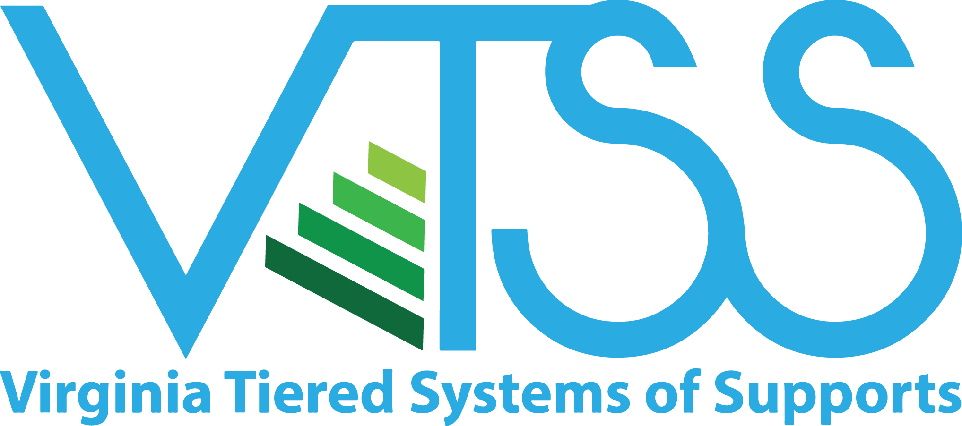
VTSS RIC Website

Virginia Tiered Systems of Supports (VTSS)
The Virginia Department of Education seeks to provide a high-quality, effective learning environment for all students and has identified this as its first priority within the Virginia Board of Education’s Comprehensive Plan 2013 – 2018. Ongoing work focuses on supporting our teachers, school, and community leaders in providing appropriate supports to a diverse student body.
To accomplish this, the Virginia Tiered Systems of Supports (VTSS) establishes a decision-making framework in divisions and schools. This framework provides a system to integrate academics, behavior, and mental health supports. The VTSS approach allows divisions, schools, and communities to provide multiple levels of supports to students in a more effective and efficient, clearly defined process.
The mission of VTSS is to build capacity for a sustained tiered system of academic, behavioral, and social-emotional supports that are responsive to the needs of all students. To accomplish this mission, VTSS seeks to:
- Promote a culture of continuous growth through on-going professional learning.
- Implement with fidelity, proactive and preventative evidence-based practices to support (improved) measureable academic and social behavioral outcomes.
- Use data informed problem solving, decision-making, screening, and progress monitoring to effectively meet instructional needs.
- Build an integrated framework that promotes shared leadership at the division, school, classroom, and community levels.

Virginia’s Vision
The vision of the Virginia Board of Education and Superintendent of Public Instruction, in cooperation with their partners, is to create an excellent statewide system of public education that derives strength from diversity and that ensures equity of opportunity for each student in a safe and healthy learning environment that prepares all students to be capable, responsible, and self-reliant citizens in the global society.

VTSS Implementation Milestones
2005 Effective School-wide Discipline (ESD) is initiated by VDOE to support schools in the implementation of positive behavior change through training and technical assistance.
2007 Response to Intervention (RtI) is initiated to provide a multi-tiered system of academic supports.
2008 ESD is rebranded as Positive Behavioral Interventions and Supports (PBIS) of Virginia.
2010 VDOE’s cascading model of support increases focus on building capacity at the division level to maximize and sustain student academic and social-behavior success.
2012 VTSS is established through the integration of PBIS and the RtI.
2013 VTSS Cohort 1 (3 divisions) receives training and technical assistance.
2014 VTSS expands to 11 additional school divisions.(Cohort 2)
2015 VTSS-Research and Implementation Center is created to continue to build state capacity to support training and technical assistance efforts.
2015 VTSS expands to 12 additional school divisions (Cohort 3).
2015 VDOE receives a federal School Climate Transformation Grant (SCTG) to enhance and scale-up systems of support for implementing evidence based, multi-tiered behavioral frameworks for improving learning conditions and outcomes for all students.
2015 VDOE receives a Project AWARE grant introducing mental health supports within the VTSS framework that is piloted in 3 school divisions.
2017 VTSS expands to 13 additional school divisions (Cohort 4). A total of 40 school divisions now receive VTSS support in order to implement a comprehensive, aligned, academic, behavioral, and social-emotional framework.

Division Leader Comments
Division leaders had opportunities to provide feedback on impacts of VTSS implementation during interviews for Cohorts 1-2 and focus groups for Cohort 3. Standout comments included:
“In the first three years of implementing PBIS, [our] school was only partially accredited. We quickly became fully accredited based on state and federal requirements. Additionally, since joining VTSS, we have lowered all overall discipline for the entire school community from 35% of students having at least one office referral to 15%.”
“Student data is the focus. The VTSS tiered-support framework helps us identify those students who really need additional academic and/or behavioral supports.”
“If kids aren’t doing well, either academically or behaviorally, staff bring data to the school data team meeting where we problem-solve, trying to figure out if this an instruction issue, a mismatch, a fidelity issue, time,…”
“…at our elementary schools last year we saw significant gains in reading and math for students with disabilities…”

VTSS School Divisions
As of December 2017, there are 40 school divisions participating in VTSS.

Cohorts 1-2
Charlottesville City
Essex County
Fauquier County
Frederick County
Greensville County
Northampton County
Orange County
Page County
Pittsylvania County
Powhatan County
Prince William County
Surry County
Westmoreland County

Cohort 3
Accomack County
Fairfax County (AWARE)
Hanover County
Madison County
Montgomery County (AWARE)
Northumberland County
Prince Edward County
Pulaski County (AWARE)
Virginia Beach City
Warren County
Waynesboro City
Williamsburg-James City County

Cohort 4
Amherst County
Brunswick County
Chesapeake City
Cumberland County
Danville City
Henrico County
Henry County
Lynchburg City
Martinsville City
Nelson County
Newport News City
Portsmouth City
Richmond City
Southampton County
Suffolk City

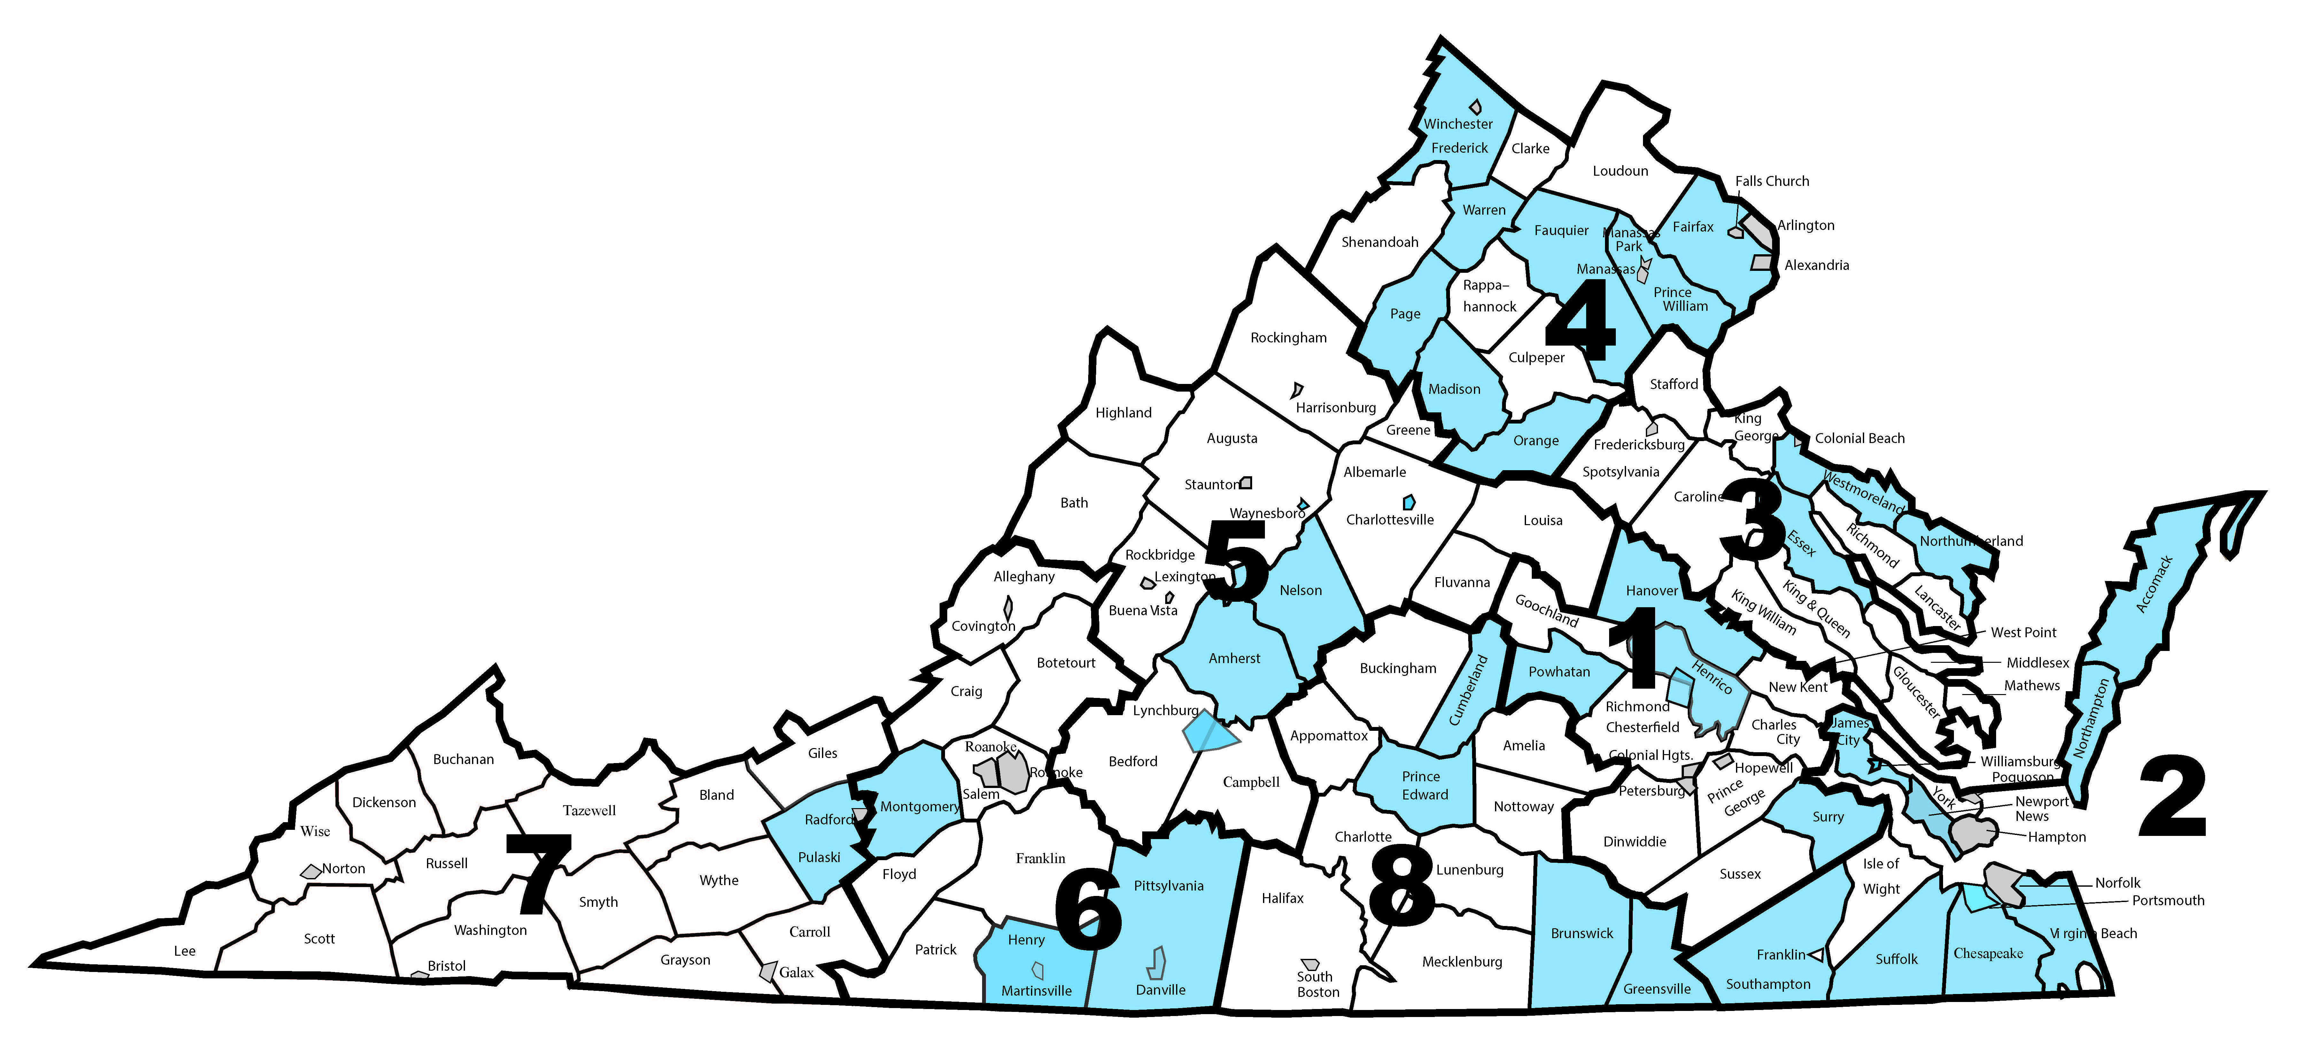

VTSS Professional Development
Evidence-based professional develop supports the establishment and sustainability of the Virginia Tiered System of Supports (VTSS) framework in school divisions across Virginia. VTSS offers regular state-wide and regional professional learning opportunities for divisions. Face-to-face and virtual opportunities to explore VTSS are provided. These events follow an established process to ensure the well-designed implementation of VTSS principles and practices. Over the past five years, division leadership teams have honed their skills in supporting and implementing VTSS in their school division. Many divisions now have VTSS coaches who have developed their skills through VTSS professional development. Participants in VTSS professional development overwhelmingly (more than 92%) report that they believe they are more skilled in implementing VTSS as a result of those learning experiences.
Between June 1, 2016 and December 31, 2017, VTSS:
- Held 35 state-wide professional learning events reaching more than 2,900 educators
- VTSS provided regional or division based professional development
- VTSS provided technical assistance and coaching to all participating VTSS school divisions
- VTSS collaborated with the VDOE and other organizations to provide the highly successful Classroom Not Courtrooms Institute.
  - In 2016, 675 educators from 101 school divisions attended.
  - In 2017, 558 educators from 88 school divisions attended.
Coaching is central to VTSS professional development. Professional development research shows that coaching significantly improves the outcomes of professional development. The VTSS includes state Systems Coaches from the VDOE Training and Technical Assistance Centers and Research and Implementation Center. These coaches partner and collaboratively assist participating school divisions. Division leaders highly value the work of the coaches in helping them implement the VTSS framework.
VTSS professional development collects event evaluation data regarding the impact of the professional development on participants. These data contribute to the on-going improvement model that VTSS uses in creating and providing professional development.
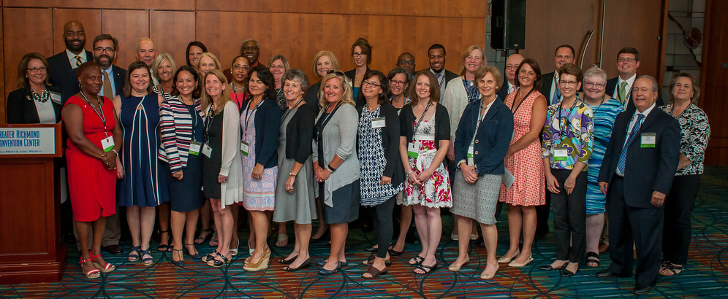

VTSS State-reported Schools
State-reported schools are schools within VTSS divisions that submit fidelity and outcome data to report to one of our funding agencies. Typically, these schools were identified as “pilot” or “demonstration” by the divisions and have received training/technical assistance from VDOE to implement VTSS. There are 38 state-reported schools within the 13 school divisions in Cohorts 1-2 and 52 state-reported schools within the 12 divisions in Cohort 3. Data results in this report will focus on results from VTSS state-reported schools.

VTSS Cohorts 1-2 State-Reported Schools

Region 1 – Powhatan County
Pocahontas Elementary
Surry County
Luther P. Jackson Middle

Region 2 – Northampton County
Kiptopeke Elementary
Northampton High
Northampton Middle
Occohannock Elementary

Region 3 – Essex County
Essex High
Essex Intermediate
Tappahannock Elementary
Westmoreland County
Washington and Lee High

Region 4 – Fauquier County
C.M. Bradley Elementary
Cedar Lee Middle
James G. Brumfield Elementary
Liberty High
Marshall Middle
Frederick County
James Wood Middle
Millbrook High
Redbud Run Elementary
Robert E. Aylor Middle
Orange County
Orange County High
Orange Elementary
Prospect Heights Middle
Page County
Luray Elementary
Page County Middle
Stanley Elementary
Prince William County
Leesylvania Elementary

Region 5 – Charlottesville City
Buford Middle

Region 6 – Pittsylvania County
Chatham Middle
Dan River Middle
Dan River Senior High
Gretna Senior High
John L. Hurt Elementary
Kentuck Elementary
Stony Mill Elementary

Region 8 – Greensville County
Belfield Elementary
Edward W. Wyatt Middle
Greensville County High
Greensville Elementary

These 13 divisions have expanded from these 38 state-reported schools to 144 schools submitting fidelity and outcome data to the VTSS data collection system.

VTSS Cohort 3 State-Reported Schools

Region 1 – Hanover County
Gandy Elementary
Henry Clay Elementary
Liberty Middle
Patrick Henry High

Region 2 – Accomack County
Pungoteague Elementary
Metompkin Elementary
Nandua High
Virginia Beach City
Bayside Elementary
Bayside Middle – Campus 6
Bayside Middle – Campus 7/8
Brandon Middle
Frank W. Cox High
Green Run High
Independence Middle
Kempsville High
Plaza Middle
Point O’View Elementary
Renaissance Academy
Strawbridge Elementary
Williamsburg-James City
Berkeley Middle
D.J. Montague Elementary
Jamestown High
Lafayette High
Lois Hornsby Middle
Matthew Whaley Elementary

Region 3 – Northumberland County
Northumberland Elementary
Northumberland Middle
Northumberland High

Region 4 – Fairfax County
Centreville High
Fairfax High
Falls Church High
Southlakes High
West Potomac High
Madison County
Madison High
Madison Primary
Waverly Yowell
William Wetsel Middle
Warren County
Brighter Futures Learning Community
Ressie Jefferies Elementary
Skyline High
Warren High
Warren Middle

Region 5 – Waynesboro City
Kate Collins Middle
Waynesboro High

Region 6 – Montgomery County
Eastern Montgomery Elementary

Region 7 – Pulaski County
Critzer Elementary
Pulaski Elementary
Pulaski High
Pulaski Middle

Region 8 – Prince Edward County
Prince Edward Elementary
Prince Edward High
Prince Edward Middle

In two years, these 12 divisions have expanded from these 52 state-reported schools to 107 schools submitting fidelity and outcome data to the VTSS data collection system.
VTSS is continuing to expand as the 15 school divisions in Cohort 4 are selecting pilot schools during the 2017-18 academic year.
As of January 2018, a total of 402 schools in 40 VTSS school divisions submit fidelity and outcome data to the VTSS data collection system.

Positive Behavioral Interventions and Supports (PBIS)
There are also divisions, not currently in a VTSS Cohort, that received training/technical assistance to implement PBIS. Some schools in these divisions continue to submit fidelity/outcome data to VTSS. AS of January 2018, there were 159 registered PBIS schools in our data collection system.

PBIS Divisions

Region 1
Chesterfield County

Region 2
Hampton City

Region 3
Caroline County
Gloucester County
King George County
Lancaster County
Middlesex County
Spotsylvania County
Stafford County
West Point

Region 4
Arlington County
Culpeper County

Region 5
Bath County
Bedford County
Greene County
Staunton City

Region 6
Franklin County
Salem City

Region 7
Buchanan County
Dickenson County
Grayson County
Russell County
Tazewell County

Region 8
Halifax County
Lunenburg County

VTSS Data
VTSS collects data during three data collection periods: New School Entry, Midyear, and End-of-Year. New School Entry establishes a school in the VTSS data collection system. Midyear collects school-level VTSS implementation fidelity using the Tiered Fidelity Inventory (TFI) and division-level capacity to implement VTSS using the Division Capacity Assessment (DCA). End-of-Year school-level data collection includes student enrollment and disciplinary outcome data including Office Discipline Referrals (ODRs), In-School Suspensions (ISSs), and Out-of-School Suspensions (OSSs) by gender, ethnicity/race, and disability type. End-of-Year division-level data collection included Value of Resources and Level of Satisfaction surveys. Data presented in the following sections is based on the 2016-17 data collection periods during which Cohort 1-3 schools were participating in VTSS.

Data Submissions
During the 2016-17 academic year:
- Midyear
  - 100% of VTSS state-reported schools
  - 96% of VTSS divisions
- End-of-Year
  - 100% of VTSS state-reported schools
  - 96% of VTSS divisions
During Midyear (MDY 2017), 90 of 90 state-reported VTSS schools submitted the TFI and 24 of 25 VTSS divisions submitted the DCA. During End-of-Year (EOY 2017), 90 of 90 state-reported VTSS schools submitted the School Profile and Outcome Summary Data form and 24 of 25 VTSS divisions submitted the Level of Satisfaction and Value of Resources.
Overall, 502 Virginia schools submitted EOY data to the VTSS data collection site.

Impact on School Discipline
From academic year 2015-16 to 2016-17, state-reported VTSS schools had a
- 5% decrease in ODRs for general education students
This decrease is based on 71 VTSS state-reported schools that submitted both EOY 2016 and EOY 2017 data without unknown values or inaccuracies. ODRs for special education students essentially remained the same changing from an average total ODRs per school of 89.70 in 2015-16 to 90.94 in 2016-17.
- 8% decrease in OSSs for general education students
- 14% decrease in OSSs for special education students
These decreases are based on 75 VTSS state-reported schools that submitted both EOY 2016 and EOY 2017 data without unknown values or inaccuracies.
It is important to note, that for over half of the VTSS state-reported schools these decreases reflect the first year of implementation and disciplinary actions are expected to continue to decrease as implementation continues and fidelity increases.
VTSS Cohort 1-2 schools have submitted outcome summary data for three consecutive years. Figure 1 shows the average total number of disciplinary actions for general education students in VTSS Cohort 1-2 schools for EOY 2015 (reflecting academic year 2014-15), EOY 2016 (reflecting academic year 2015-16), and EOY 2017 (reflecting academic year 2016-17). Average disciplinary actions (ODRs, ISSs, and OSSs) for general education students decreased from EOY 2015 to EOY 2017.
Figure 1. Average Total Number of Disciplinary Actions for General Education Students in VTSS Cohort 1-2 Schools

Figure 2 shows the average total number of disciplinary actions for special education students in VTSS Cohort 1-2 schools for EOY 2015, EOY 2016, and EOY 2017. Average ISSs and OSSs for special education students decreased from EOY 2015 to EOY 2017.
Figure 2. Average Total Number of Disciplinary Actions for Special Education Students in VTSS Cohort 1-2 Schools

Impact on Administrative and Instructional Time
A cost-benefit analysis using Virginia’s ODR data estimates that VTSS implementation saved on average (EOY 2015 – EOY 2017)
- 1.07 instructional hours per week
- 2.13 administrative hours per week
These estimates of instructional and administrative time saved are based on an average of 20 minutes ODR process time, 10 minutes of out of class time per ODR, and are calculated using a school year consisting of 180 school days with 5 day weeks (average minutes × 5 / 60).

Tier Analysis
In a multi-tiered system of supports framework, student supports are tiered as follows:
- Tier I: Universal supports for ALL students.
- Tier II: Targeted group supports for SOME students.
- Tier III: Individual supports for a FEW students.
In Positive Behavioral Interventions and Supports (PBIS), a component of VTSS, a student with 0-1 ODRs receives Tier I supports, 2-5 ODRs Tier II supports, and 6 or more ODRs Tier III supports. Ideally, a school should have no more than 20% of the student body receiving Tier II supports and no more than 5% of students receiving additional Tier III supports. Figure 3 shows the standard student enrollment by tier (80% Tier I, 15% Tier II, and 5% Tier III) and the average tier enrollment for VTSS state-reported schools in 2016-17.
VTSS state-reported schools have less than the standard percent of students in Tiers II and III.
Thus, fewer students require higher intensity supports!
Figure 3. Student Enrollment by Tier
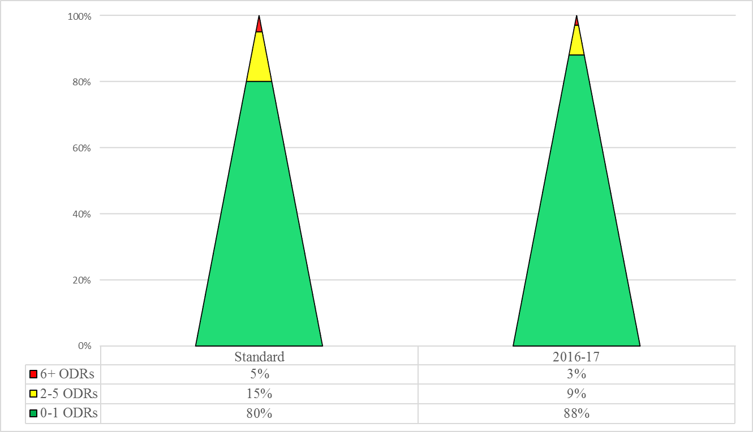

Mental Wellness
The integration of mental wellness into the VTSS framework is a priority of VDOE and is supported, in part, by a Project AWARE grant from the Substance Abuse and Mental Health Services Administration (SAMHSA). This work began in 2015 with three pilot LEAs. The three Project AWARE LEAs serve as the pilot sites to develop a multi-tiered model that integrates a comprehensive and efficient systems approach for addressing the mental health needs of school-aged (K-12) youth that will benefit all schools in the future.
One component of this work is to implement and expand the availability and delivery of Youth Mental Health First Aid (YMHFA/Adult) throughout the Commonwealth to increase early identification and intervention in cases of mental health distress in Virginia's youth and reduce the mental health stigma in the schools and wider communities. Since 2015, more than 3,300 adults have been trained in YMHFA as first-aiders, and 7,835 students have received referrals to mental health resources and/or services.
The LEAs have worked hard to establish data systems that allow them to track student outcomes and make data-based decisions. Some major findings from the first 3 years of this work include:
- Over 3,180 students were served by school-based mental health professionals during the 2016/17 academic year; an increase of 91% from baseline.
- During 2016-17, 72% of students who were referred to community-based mental health services actually received services; an increase of 4% from baseline.
- The number of evidence-based programs being implemented in Project AWARE schools increased from 20 in 2015-16 to 79 in 2016-17. These programs are expected to impact mental health related risk and protective factors. The most commonly identified evidence-based programs are Positive Behavioral Interventions and Supports (PBIS) and Student Assistance Programs (SAP).
- Rates Office Discipline Referrals, In-School Suspensions, and Out-of-School Suspensions have decreased in the Project AWARE schools, in most cases for both general education students and students with IEP/504 plans.
- Measures of school climate, as represented by school safety data, demonstrate promising trends in decreased offenses against other students and staff, ATOD-related, property-related, and disorderly or disruptive behavior. While it is impossible to tease out the potential effects of Project AWARE activities on these school safety outcomes, these trends are encouraging, and the team will continue to track them in Year 4 of the project.
Research and Implementation Center
Supported by the Virginia Department of Education, the Research and Implementation Center at the Virginia Commonwealth University Center for School-Community Collaboration (VTSS-RIC) strived to build state and local capacity for a sustained tiered system of academic, behavioral, and social-emotional supports that are responsive to the needs of all students.

Partners
- Virginia Department of Education
- VTSS Research and Implementation Center at the Virginia Commonwealth University Center for School Community Collaboration
- Old Dominion University
- University of Kansas Center for Research on Learning
- Formed Families Forward
- Virginia Department of Education’s Training and Technical Assistance Centers at:
  - College of William and Mary
  - George Mason University
  - James Madison University
  - Old Dominion University
  - Radford University
  - Virginia Commonwealth University
  - Virginia Tech

Sponsors
- Virginia State Personnel Development Grant, Office of Special Education Programs, U.S. Department of Education, Award #H323A120026
- Virginia School Climate Transformation Grant, Office of Safe and Healthy Students, U.S. Department of Education, Award #S184F140020
- Virginia Project AWARE, Substance Abuse and Mental Health Services Administration, Department of Health and Human Services, Award #H79SM061987
- Virginia General Assembly Funds
TO REQUEST ASSISTANCE CONTACT:
Research and Implementation Center
3600 West Broad Street, Suite 117
Box 980626
Richmond, Virginia 23298-2020
(804) 828-1482
Email: vtssric@vcu.edu

