Trauma-Sensitive Response to Interventions for Behavior Sort
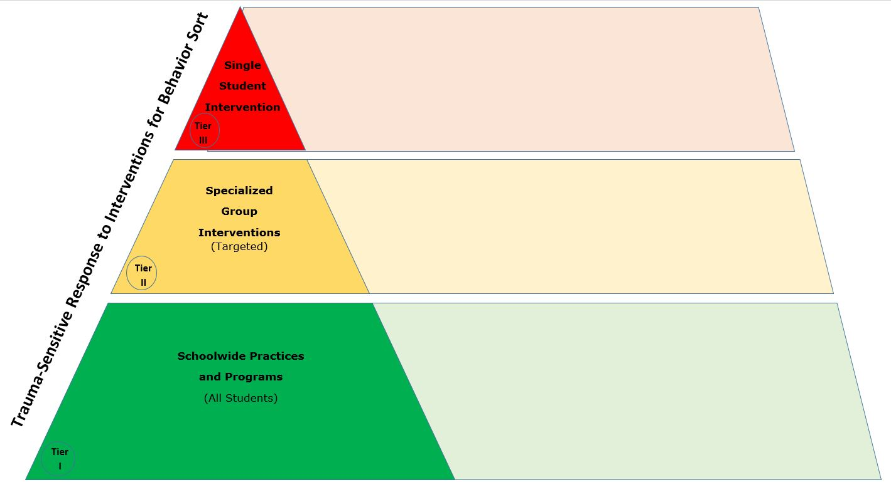

Tier | Tier Description | Resources
Tier III | Single Student Intervention
Tier II | Specialized Group Interventions (Targeted)
Tier I | School-wide Practices and Programs

