Infographic Module 1: Introduction to trauma and becoming a trauma sensitive school

What?
The Substance Abuse and Mental Health Services Administration (SAMHSA) defines trauma as results from an event, series of events, or set of circumstances that is experienced by an individual as physically or emotionally harmful or life threatening and that has lasting adverse effects on the individual's functioning and mental, physical, social, emotional, or spiritual well-being.
Abuse
Poverty
Neglect
Discrimination ← Depict highlighted words with word and image (see example linked below)
Loss/Grief
Accident/Illness
Natural Disaster
Bullying

Why?
Trauma effects:
Brain
Learning
Relationships ← Depict highlighted words with word and image (see example linked below)
Behavior
World View
If we put trauma sensitive supports in place, fewer students will need more intensive interventions. Trauma sensitive supports:
- are what is best for all students
- remove Barriers
- make things equitable for all students
- have a positive impact on school functioning
- build community resilience
- establish safe and stable Relationships

How?
We are able to reduce the impact of trauma through the implementation of trauma-sensitive supports. Trauma-sensitive is defined as a framework in which schools acknowledge the high prevalence of traumatic exposure for students, the importance of staff well-being and strives to meet the unique needs of all learners. (Black, P., Cook, E. & Daniel, S. 2017)
We implement trauma-sensitive supports through the VTSS implementation Logic: data, practices, systems, and outcomes.

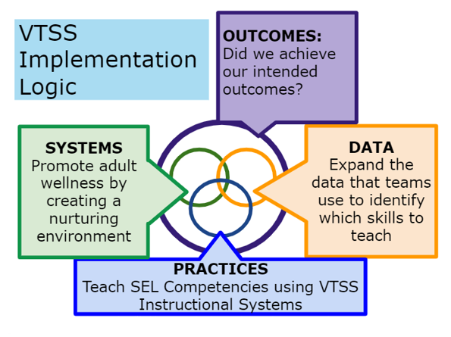

Support | Description
Outcomes | Did we achieve our intended outcomes?
Systems | Promote adult wellness by creating a nurturing environment
Data | Expand the data that teams use to identify which skills to teach
Practices | Teach SEL Competencies using VTSS Instructional Systems

