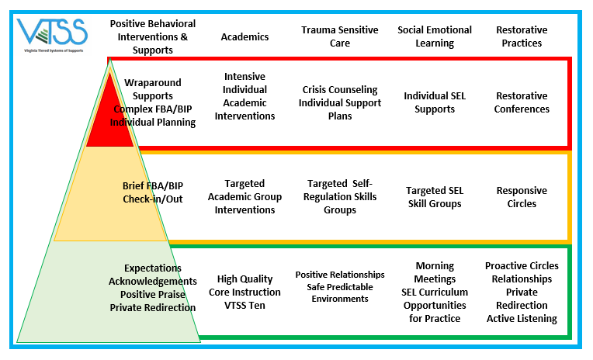

Tier | Positive Behavioral Interventions & Supports | Academics | Trauma-Sensitive Care | Social Emotional Learning | Restorative Practices
Tier III | Wraparound Supports  Complex FBA/BIP  Individual Planning | Intensive  Individual  Academic Interventions | Crisis Counseling Individual Support  Plans | Individual SEL Supports | Restorative Conferences
Tier II | Brief FBA/BIP  Check-in/Out | Targeted  Academic Group Interventions | Targeted Self-Regulations Skills Groups | Targeted SEL  Skills Groups | Responsive  Circles
Tier I | Expectations Acknowledgements Positive Praise Private Redirection | High Quality  Core Instruction VTSS Ten | Positive Relationships  Safe Predictable Environments | Morning  Meetings  SEL Curriculum  Opportunities for Practice | Proactive Circles  Relationships  Private  Redirection  Active Listening

